CURRICULUM VITAE
KARIM ALHASSAN AZURE
Telephone: +233241500105 E mail: linslim15@yahoo.com
PERSONAL INFORMATION
Sex: male
Date of birth: 30/07/1992
Nationality: Ghanaian
Marital status: single
Language spoken: English basics Twi, Hausa
Position: midfielder defensive midfielder
Height: 1.90cm
Weight: 72kgs
PROFILE
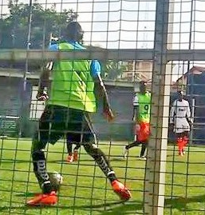
Versatile, dedicated good team player and also has the ability to develop productive relationship with colleagues at all level and also has a personal drive for excellence self-discipline. Am also fast on ball and can shoot from any angle when playing. I am strong and skillful on the ball.

EDUCATIONAL BACKGROUND
Institution YEAR START YEAR COMPLETED CERTIFIED
Laterbiokorshie 1 and 2 Junior Secondary School 2006 2009 BECE
Zamse Senior High School 2009 2013 WASSCE
Koforidua Technical University 2016 2018 DIPLOMA

EXPERIENCE AND ACHIEVEMENT
Played My First Team In The Year 2000 Dansoman Leeds United Played As A Left Backer And Midfielder To The Year 2005, , Played A School Team In The Year 2006 To 2009 As A Defensive Player, (Larterbiokorshie1) Jhs. Played In My Secondary School (Zamse Senior High) Shs In The Year 2010 To 2013 As A Right Backer. Played Soccer Stars Fc As A Right Winger
Team Address Contact
Dansoman Leeds Fc ------------------------- 0543529981
Larterbiokorshie 1 P.O.Box 970 Mamprobi 0268190669 Zamse Secondary School P.O.Box 205 Bolgatanga U.E.R 0242132588
Soccer Stars Fc P.O.Box 748 Bolgatanga U.E.R 0209430306

SKILLS AND ABILITIES
- Sprinting Stamina
- Shooting Balance
- Passing Jumping
- Intelligence (Game Understanding)
- Composer (Ability to Control Game in Critical Situation)

HOBBIES
Watching and Playing Football
REFERENCE
Coach Foster
Tel: 0242932588
Mr. Agongo Fred
Tel: 0209430306
Coach Annai
Tel: 0543529981
Mr. Peter Fletcher Lartey
Tel: 0268190669

